ACCESS Loan Program Brochure

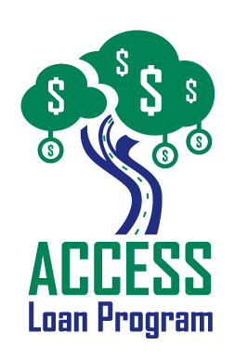
Measures 8 ½ x 11 inches (folded in half)

Since its inception in 2001, Commerce Lexington’s ACCESS Loan Program has led to more than $22 million in financing for the expansion of small and minority-owned businesses in Central Kentucky. It has received regional, statewide, and national recognition. Different than traditional applications for loans, the ACCESS Loan Program brings the financial institutions to the client. Applicants know exactly where they stand when it comes to financing for a business. The ACCESS Loan Brochure is the program’s main marketing tool and reaches a regional audience.

Publication Date: Updated throughout the year

Frequency: Annual

Projected Circulation: 1,000+. Distributed to financial institutions, local and state government economic development offices, including area Chambers of Commerce, Small Business Development Centers, Community Ventures, and organizations throughout the Bluegrass Region participating in the program, which in turn distribute them to potential loan applicants. The program and brochure are targeted to minority, women-owned, and small business entrepreneurs.

Contact: Mark Turner, 859-226-1606, mturner@commercelexington.com for specifications

Description | Price | Ad Size
Ads on outside back cover | $150 each | 5.0’’ x 1.5’’

