Guide to Gaining Media Attention

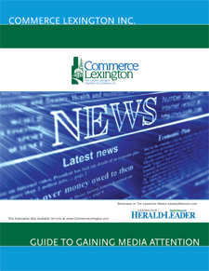
Measures 8.5’’ x 11’’ (multiple pages)

This publication is designed to assist businesses and non-profit organizations in utilizing the local media more efficiently. It includes everything from how to structure a news release to what’s the best way to contact a media representative, as well as a list of local media outlets.

Publication Date: February 2020

Publication Circulation: 500, distributed to new members and on request

Medium: Printed and electronic versions; Posted on-line at www.commercelexington.com/publications.html

Contact: Mark Turner, 859-226-1606, mturner@commercelexington.com

Description | Price | Ad Size
Outside Back Cover | $750 | 7 ½’’ x 10’’ (no bleed)
Inside Front Cover | $650 | 7 ½’’ x 10’’ (no bleed)
Inside Back Cover | $625 | 7 ½’’ x 10’’ (no bleed)
Half-page ad inside | $300 | 7 ½” x 5”

