Legislative Focus

Format 8.5’’ x 11’’ (multiple pages)

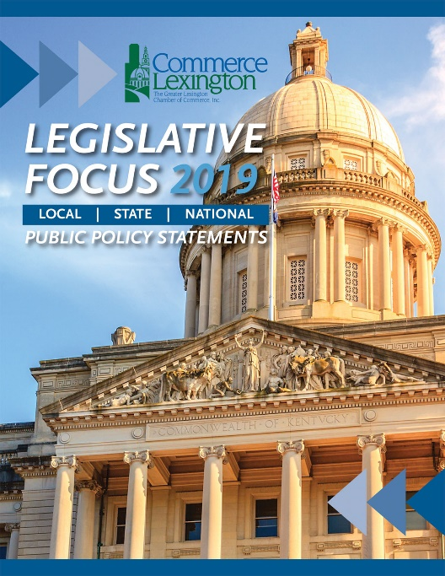
Commerce Lexington’s Legislative Guide and Public Policy Statements brochure outlines the organization’s policy statements for the upcoming Legislative Session. Each year, Commerce Lexington’s Public Policy Council meets to formulate the organization’s policy positions on a number of issues – from education to workforce development to taxes and more.

Publication Date: December 2019/January 2020

Frequency: Annual

Projected Circulation: 5,100 published in the Business Focus magazine in December or January, and additional copies are distributed to key leaders in the community as well as those interested in the political and policy-making process.

Medium: Printed and electronic version available on www.commercelexington.com

Contact: Mark Turner, 859-226-1606, mturner@commercelexington.com

Description | Price | Ad Size
Outside Back Cover | $1,500 | 7 ½’’ x 10’’ (no bleed)
Inside Front Cover | $1,250 | 7 ½’’ x 10’’ (no bleed)
Inside Back Cover | $1,100 | 7 ½’’ x 10’’ (no bleed)

