Minority Business Resource Guide

Measures 8.5’’ x 11’’

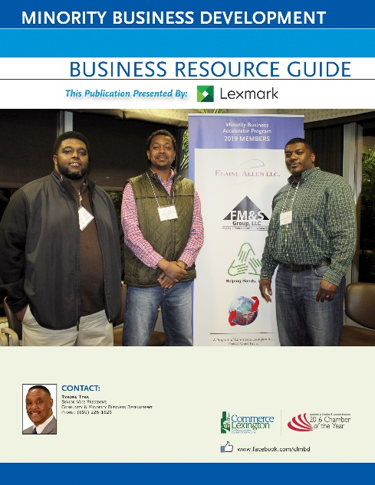
Commerce Lexington’s Minority Business Resource Guide is an important tool for the Minority Business Development Program. In addition to listing the contact information of minority members of Commerce Lexington, it also features programs and services that can benefit minority-owned businesses. It’s great for companies looking to do business with minority and women businesses.

Publication Date: June 2020

Frequency: Annual

Projected Circulation: 600+ (Distributed at Commerce Lexington events including the Opportunity Exchange Reception, purchasing directors at the areas larger companies including UK, LFUCG, FCPS, as well as potential applicants to Commerce Lexington’s Access Loan Program)

Medium: Printed and electronic versions online at www.commercelexington.com.

Contact: Mark Turner, 859-226-1606, mturner@commercelexington.com for specifications

Description | Price | Ad Size
Outside Back Cover | $1,200 | 7 ½’’ x 10’’
Inside Front Cover | $1,000 | 7 ½’’ x 10’’
Inside Back Cover | $800 | 7 ½’’ x 10’’
Half-page ad inside | $500 | 7 ½” x 5”
Quarter-page ad inside | $250 | 3 ½” x 5”

Renewals pending with KCTCS (back cover), Cornerstone Engineering (1/2-page), Fayette Co. Public Schools (1/4-page), LFUCG (1/4-page), and Valvoline (half-page).

