Small Business Resource Guide

Measures 8.5’’ x 11’’ (12 pages)

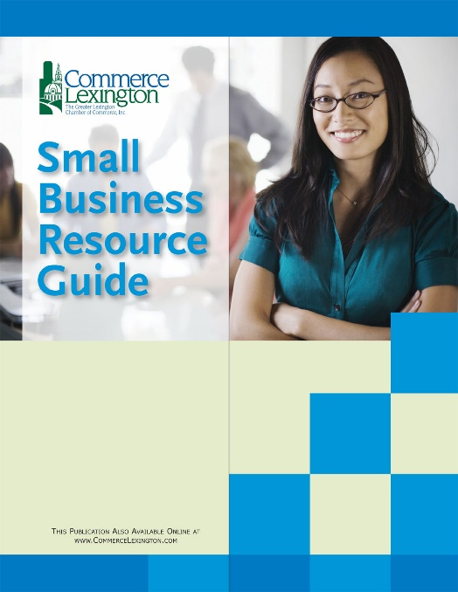
Commerce Lexington’s Small Business Resource Guide is a step-by-step plan for starting a small business. This guide is extremely helpful to local entrepreneurs who may have difficulty figuring out where to start. Included in the guide is information about the Bluegrass Small Business Development Center for help creating a business plan, and Commerce Lexington ACCESS Loan contact information.

Publication Date: March 2020

Frequency: Annual

Projected Circulation: 500 print, downloadable online at www.commercelexington.com

Medium: Printed & available online at www.commercelexington.com/publications.html.

Contact: Mark Turner, 859-226-1606, mturner@commercelexington.com

Description | Price | Ad Size
Outside Back Cover ad | $750 | 7 ½’’ x 10’’ (No bleed)
Inside Front Cover ad | $650 | 7 ½’’ x 10’’ (No bleed)
Inside Back Cover ad | $625 | 7 ½ x 10’’ (No bleed)
Half-page ad inside | $300 | 7 ½” x 5”

